
Systems Settings
Systems Settings
PRODUCT: Damstra Workforce Management

VERSION:

AUTHOR: J-pee De Guzman

APPROVED BY:

In systems settings, you can update your company details, set up branches for your company and set up users to able to log into the EPP for companies.

Navigation

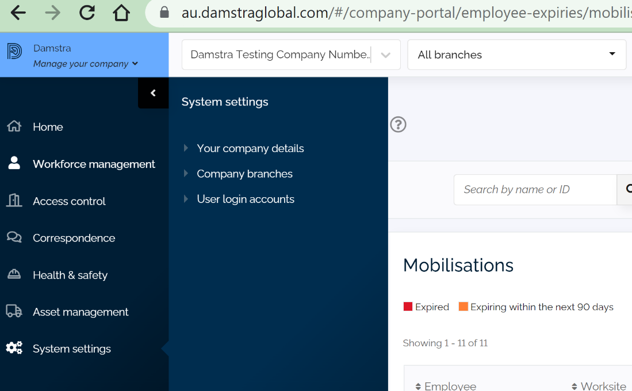

Please click Your Company details to update information on your company:

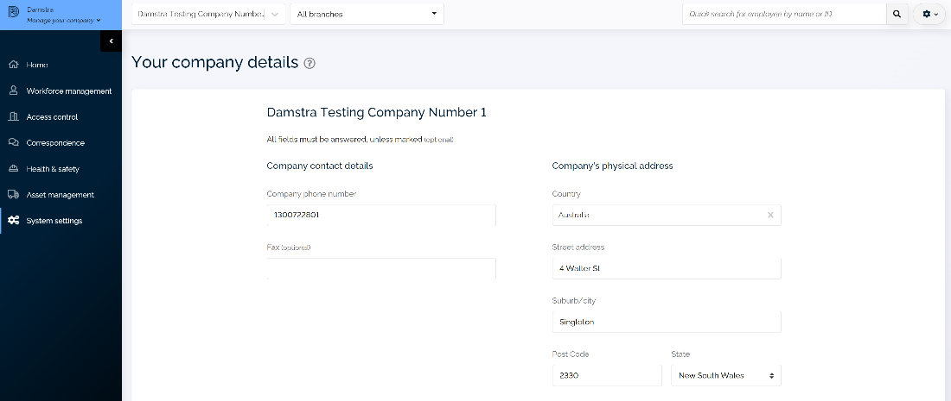

Please click Company branches to find out more information on branches set up by your company as well as create new branches:

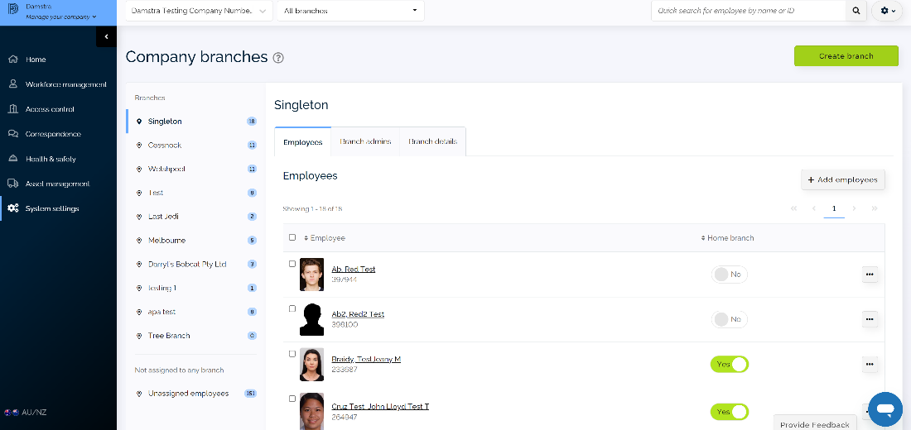

Please click on User log-in accounts to view current users of the EPP for companies and create logins for new company users.

