
Workforce management – Employee profile
Workforce Management - Employee Profile
PRODUCT: Damstra Workforce Management

VERSION:

AUTHOR: J-pee De Guzman

APPROVED BY:

All employees

All employees allows company users to access information on all employees that are registered for their company.
All employees page is accessed via the left sided navigation by clicking Workforce → All employees.

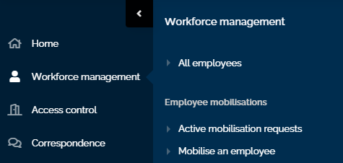

In the All employees page you can

- Search for an employee
- View all employees register for your company
- View an employee profile.
- Mobilise an employee.

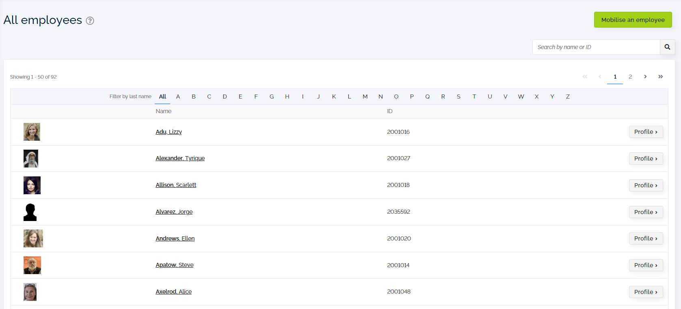

Employee profile overview

The employee profile page is accessed via all employees page. The all employees page can be accessed via the left-sided navigation by clicking Workforce management --> All employees menu item.

The employee profile page allows company users to view and manage employees registered for their company. This includes:

- Employee top summary
- More
- Items on employee's profile

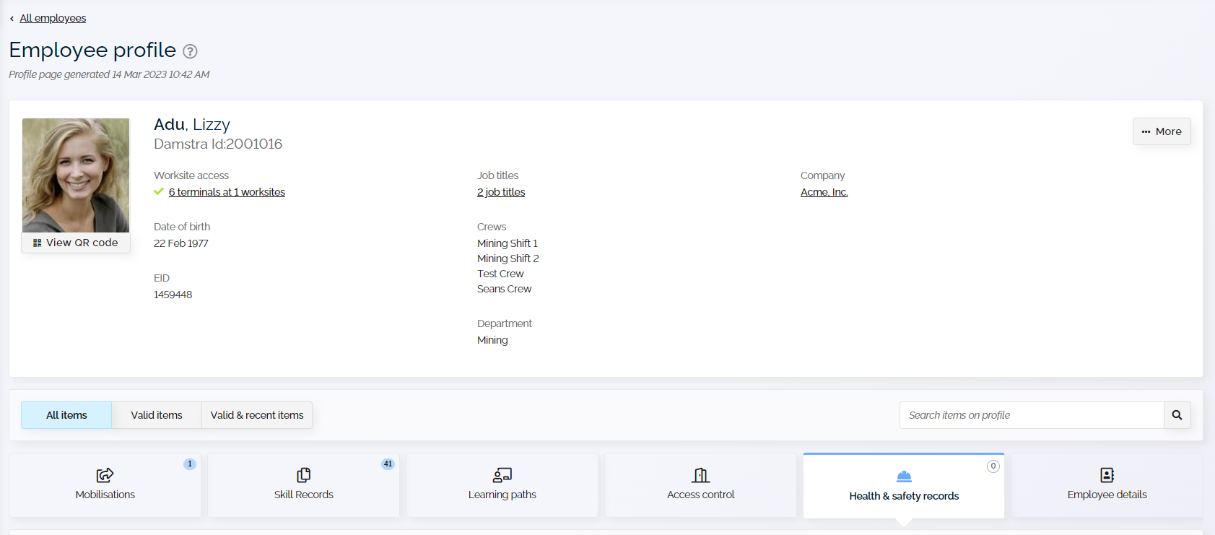

Users will be directed to the employee profile page that displays the following:

- Employee profile top summary

Employee profile top summary is located on the top of the employee profile page. This section allows company users to view information on employee's profile e.g. worksite access, crews, company, job titles etc. To find out more about this section please click here.

- More

More drop-down menu is located on the top right of the employee profile page. This section displays various tasks and actions that a user can undertake based on their permission level. To find out more about this section please click here.

- Items on profile

Items on the profile section are located under the top summary. This section allows users to view mobilisations, skills records, access control related items, health and safety records and employee details on the employee’s profile page. To find out more about this section please click here.

Top summary of the employee profile page

The top summary section is located on the top of the employee profile page. This section allows users to view important information on the employee's profile page.

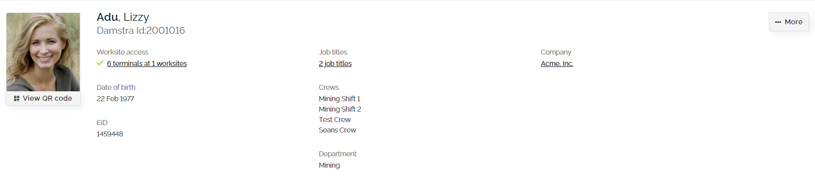
- Employee details
The following details are shown on the employee profile:
- Shows the employee profile photo with a QR code
- Shows the full name of the employee
- Shows the Damstra ID of the employee
- Shows the list of job titles
- Shows the list of crews
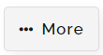
- More menu
The dropdown menu is located on the top right of the employee profile page. This section allows users to remove employees from their company.
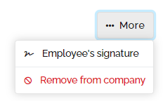

Items on profile of the employee profile page
Items on profile section is located below the top summary employee profile page. This section allows users to view the following for their employees.
- Mobilisations
- Skill records
- Access control
- Health and safety records
- Employee details
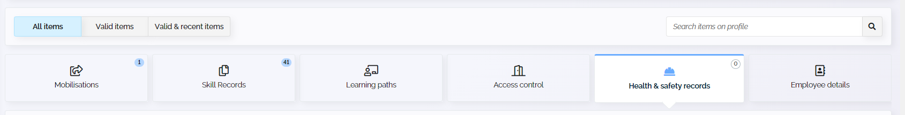

- Mobilisations
This section located on the employee profile page users to view information on inductions and registration details on the employee's profile page. The following details are shown in this section:

- Worksite
- Mobilisation
- Mobilistation status
- Start date
- Expiry date

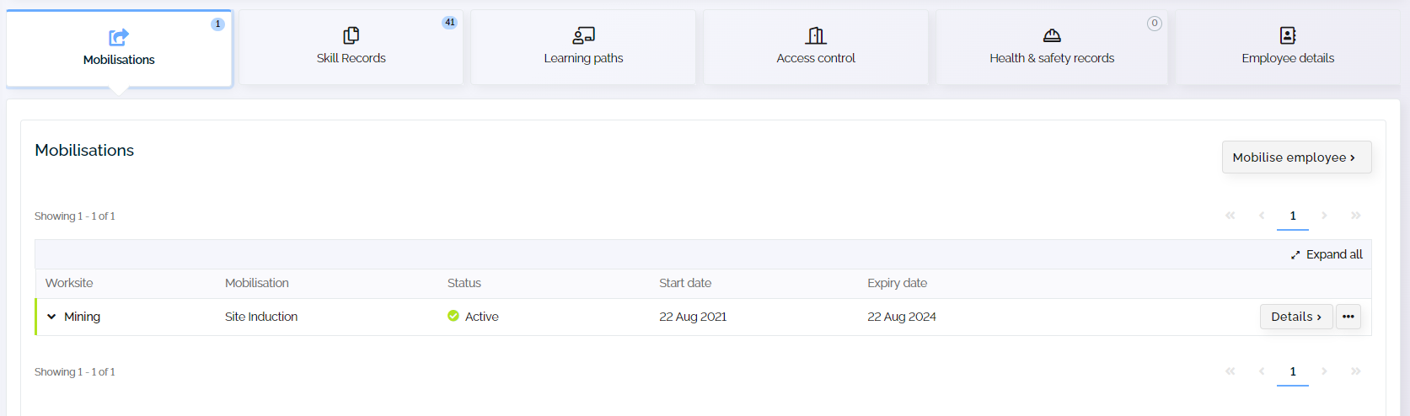

Notes:

- Enter a keyword in the search item bar located on the top right to narrow down the desired search result.
- Click located next to the requirements button to view history

- Click on to expand and view additional details & attachments for the selected mobilisation.
- Click on 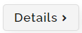 to open employee's details page on a separate browser page.

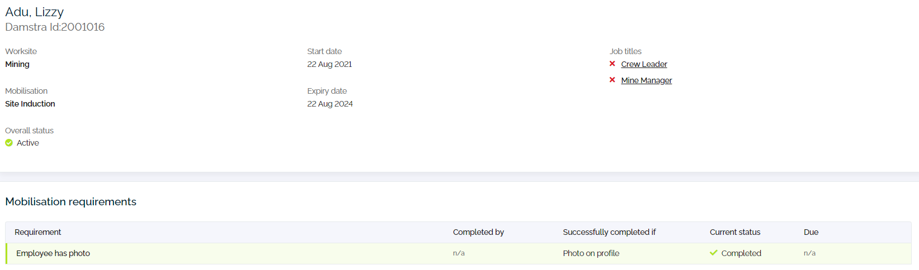

The following information is shown on the details page:
- Top summary
- Worksite
- Employee details
- Mobilisation name
- Job titles
- Mobilisation requirements
- Requirement
- Successfully completed if
- Current status
- Due
Click on to expand and view additional details & attachments for the selected requirements.
Click on 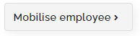to begin a mobilisation request.

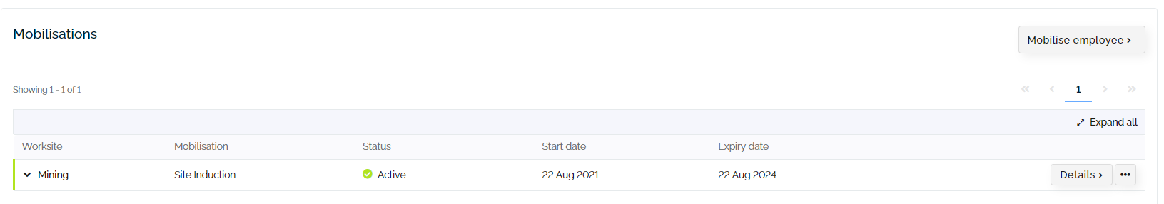

- Skill records
This section allows users to view skill records on the employee's profile page. The following skill records are shown on the page.
- Qualifications
- Worksite skills
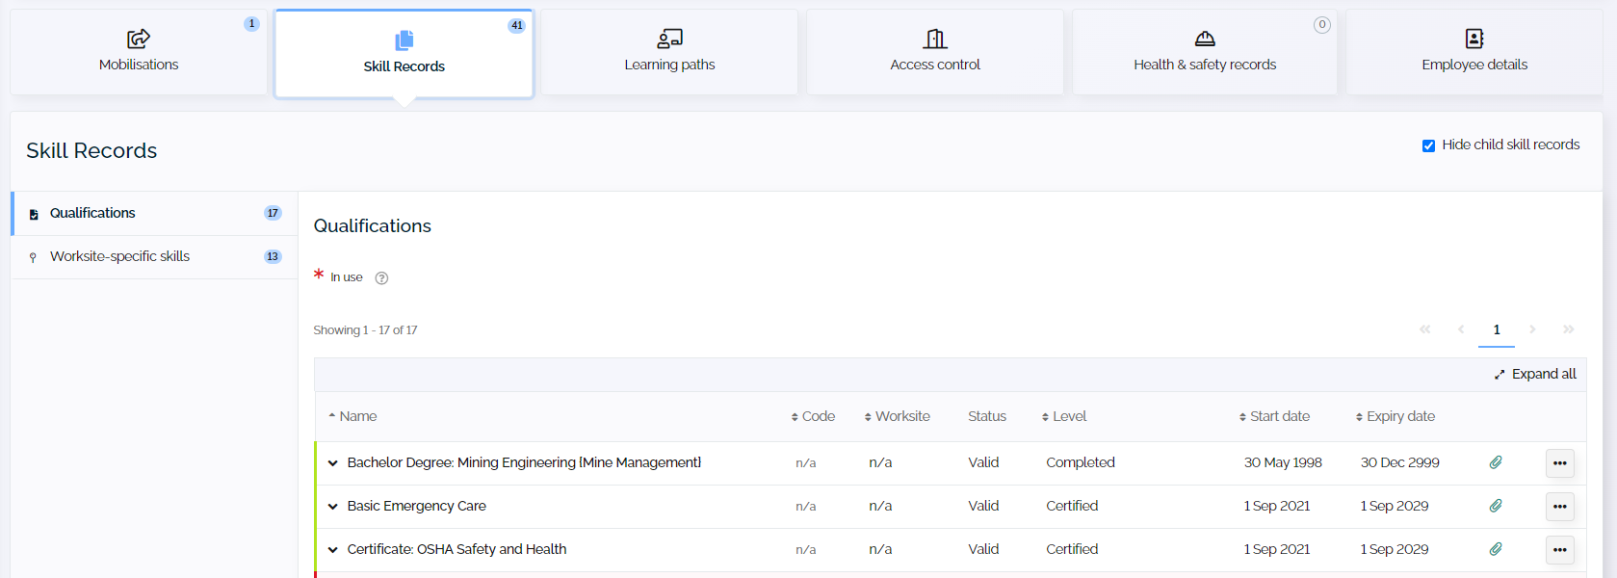

Qualifications
The following details are shown on the page
- Skill name
- Skill code
- Worksite
- Status
- Level
- Start date
- Expiry date
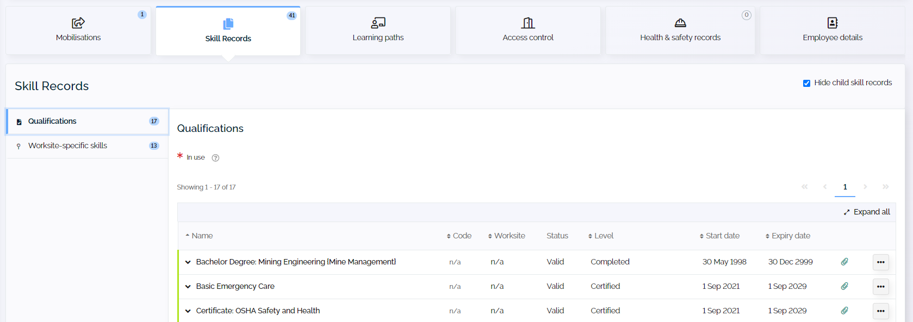

Worksite skills
The following details are shown on the page
- Skill name
- Skill code
- Worksite
- Status
- Level
- Start date
- Expiry date
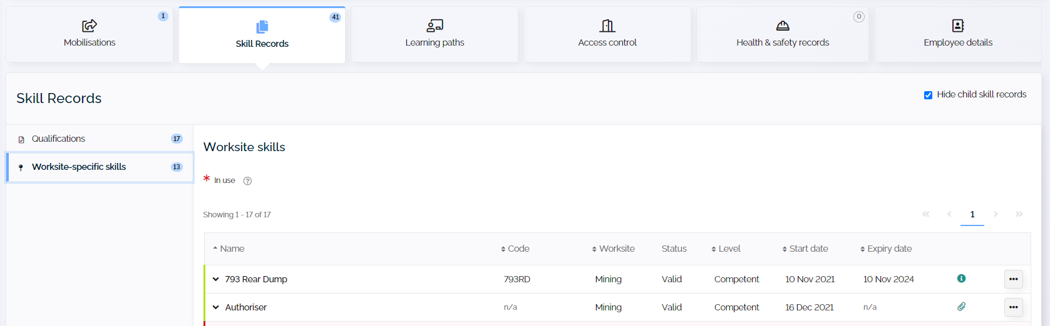
- Enter a keyword in the search item bar located on the top right to narrow down the desired search result.
- Click on to expand and view additional details and attachments for the selected skill.
- Click on  to view skill record (version) history 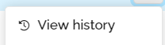

- Access Control
This section allows users to view access records and reports on the employee's profile page. The following information is shown on the page.
- Timecards
This section of the access control tab opens the employee's timecard that displays the employee's shift activity during any given date range. The following information is displayed on the employee's timecard:
- Day of week
- Date worked
- Shift start time
- Shift end time
- Total shift hours
- Total worked hours in the last 7 days.
- Origin
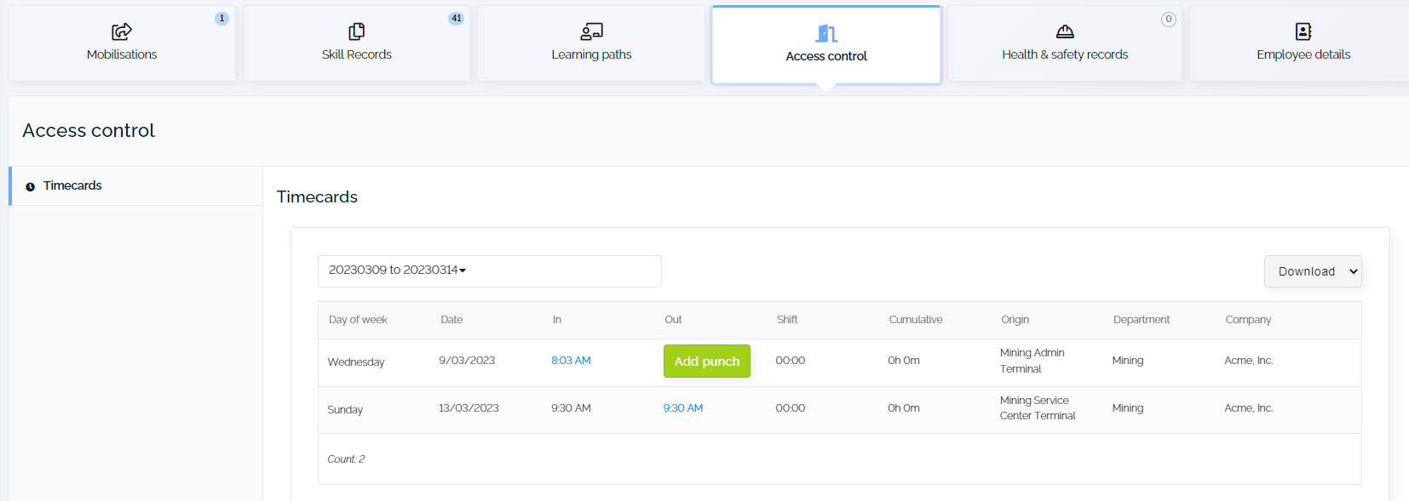

- Health & safety records
This section of the employee profile page allows users to view health and safety records including;
- Medical
- Drug & alcohol tests
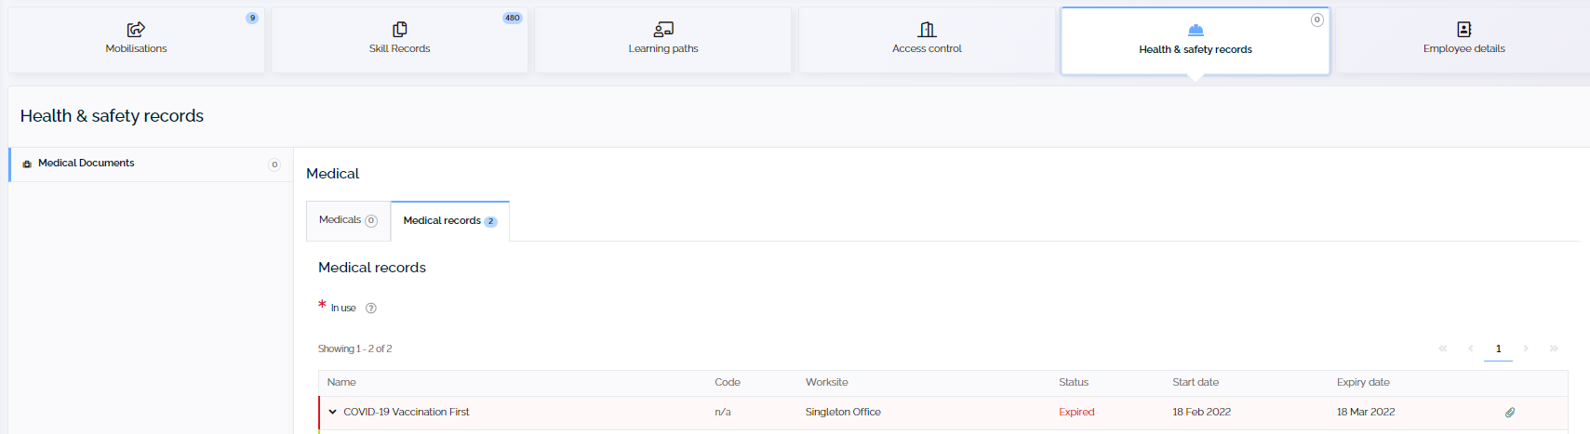

- Employee details
This section allows users to view employment details on the employee’s profile page.

