
Self-Verification – Employee Documents
PRODUCT: EPP/WFM

VERSION:

AUTHOR: J-pee De Guzman

APPROVED BY:

Self-verification of Employee Documents in EPP worksite users:

- Full control over their employee’s worksite documents/requirements that have been declined or expired.
- Ability to view, verify, approve, decline, and lock employee document/requirement
- Eliminates the need to contact Damstra service desk
- Increase process efficiency

Employee Documents

Employee Documents can be accessed by going to Actions → All verifications → Employee documents.

  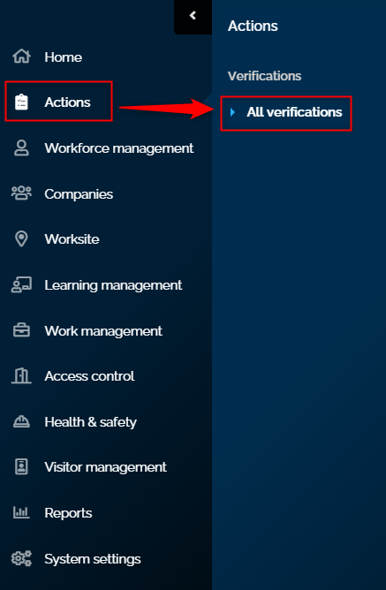 | 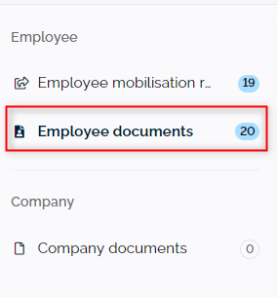

The Employee documents will display all the outstanding documents that were uploaded from different pages of EPP:

- EPP for Companies – Active Mobilisation Requests → Attention Required
  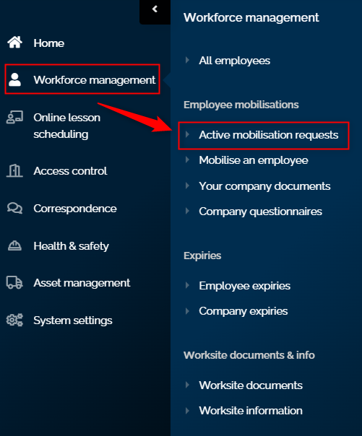 | 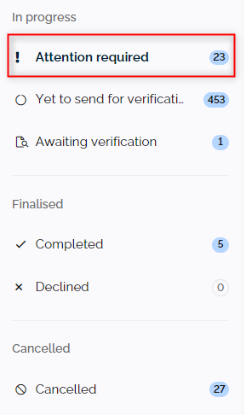

- Expiries Page – Employee expiries and Company expiries

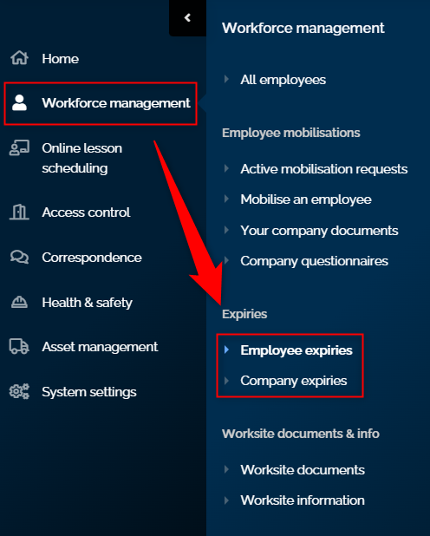

- Employee Profile – Manage Worksite, Manage your Company, and Your Employee Account
- Learning Pathways – Company and Employee

How do you verify employee documents?
- Select and expand the employee document request by clicking the
- Click to open the review document window that displays employee details, document details, and overall action.
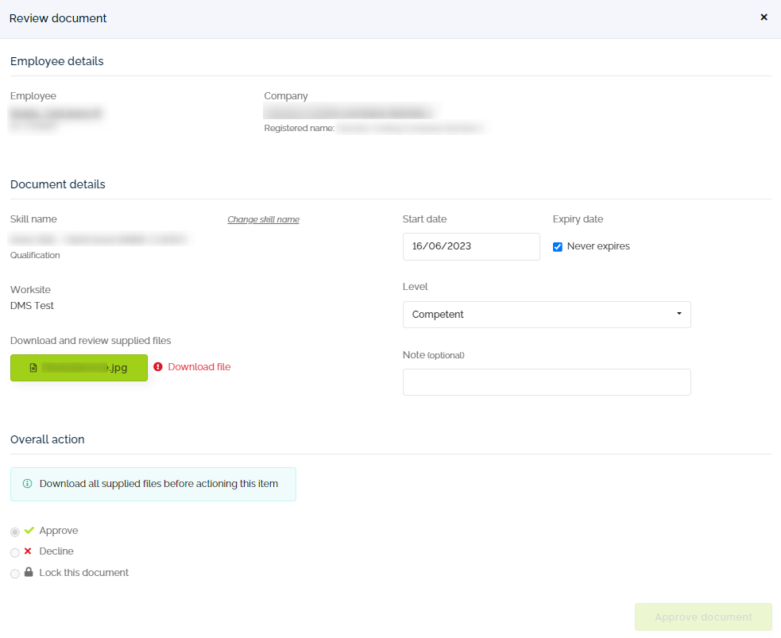

- Click the attachment to open and review the document. Skill name can be modified if needed.

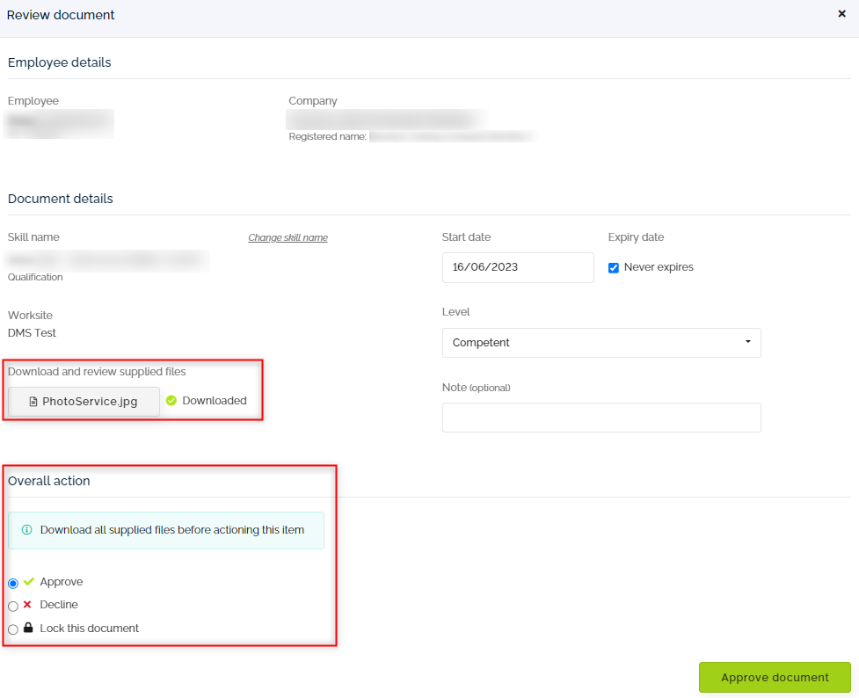

- Approve, reject, or lock the document based on the worksite’s rules or criteria.

