
Workforce management - Employee Mobilisations
Workforce Management - Employee Mobilisations
PRODUCT: Damstra Workforce Management

VERSION:

AUTHOR: J-pee De Guzman

APPROVED BY:

Employee Mobilisations Overview

Employee mobilisations menu section is accessed via the left side navigation by clicking Workforce management → Employee Mobilisations.

This section includes;
- Mobilise an employee
- Active mobilisation requests
- Your company documents
- Company questionnaires

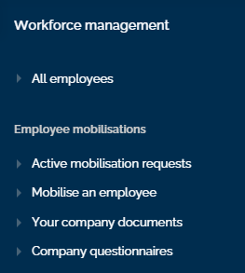

- Active mobilisation requests
This section allows company users to view and manage active mobilisations that require attention, are in progress and are confirmed or declined.

- Mobilise an employee
This section allows company users to add and mobilise employees to required worksites.

- Your company documents
This section allows users to view, manage and maintain their company documents that are required to complete mobilisation requests.

4. Company questionnaires
This section allows users to view company questionnaires that are required to complete mobilisation requests.

Mobilise an employee overview

Mobilise an employee is accessed via the left side navigation by clicking Workforce management -→ Employee mobilisations → Mobilise an employee. This section allows company users to add and mobilise employees to required worksites.

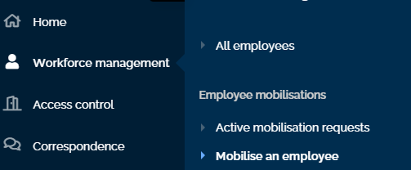

To begin mobilisation select who is being mobilised and the worksite they are being mobilised for. Users can mobilise an existing employee that has previously been mobilised or a new employee.

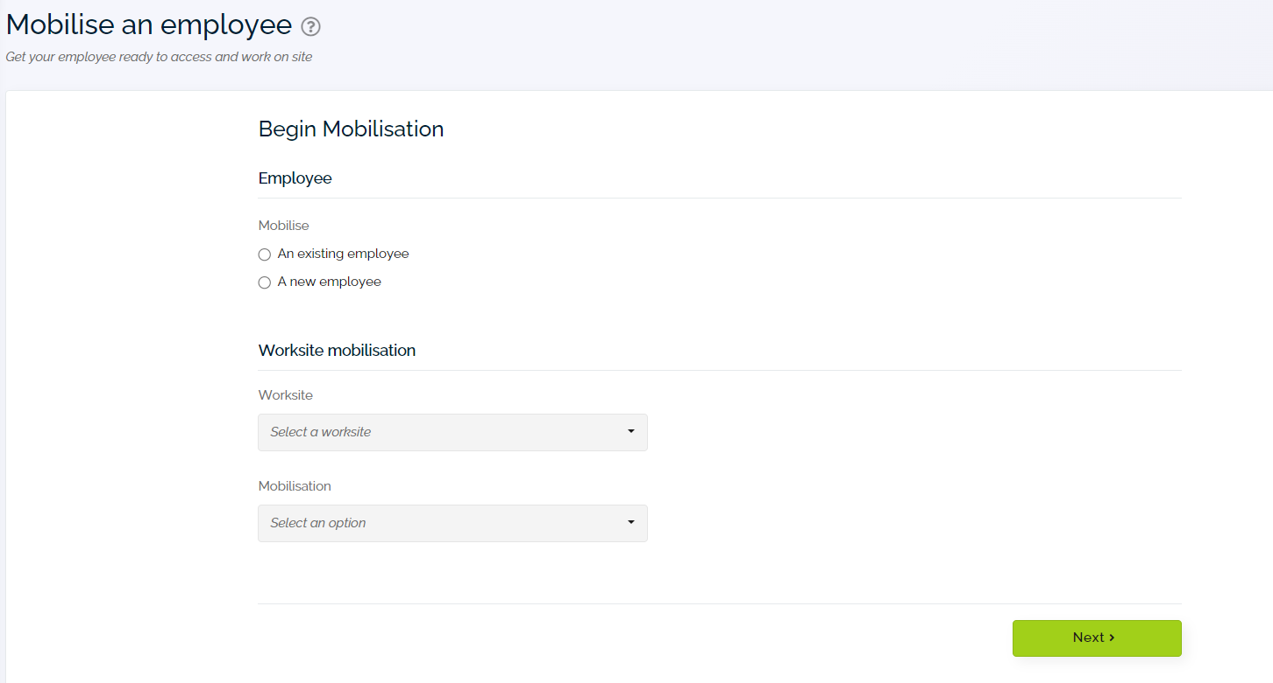

Once the employee and worksite and mobilisation is selected employee, worksite and mobilisation specific requirements are completed and the mobilisation sent for verification.

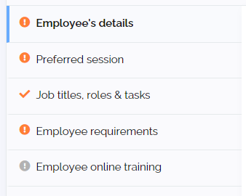

Icons will indicate the overall status of each section.
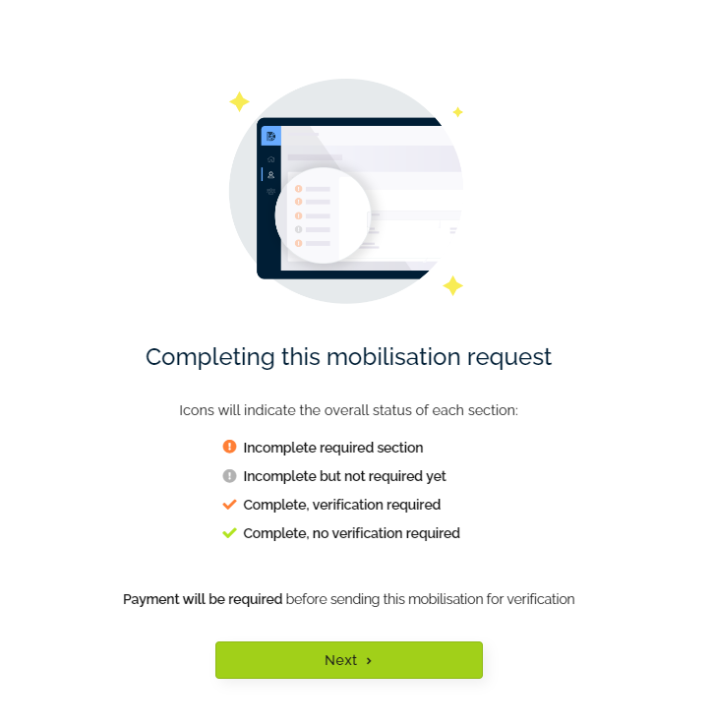
Alert banner will show if there are outstanding company requirements.

