
Workforce management – Expiries
Workforce Management - Expiries
PRODUCT: Damstra Workforce Management

VERSION:

AUTHOR: J-pee De Guzman

APPROVED BY:

Expiries menu section is accessed via the left side navigation by clicking Workforce management → Expiries.



This section allows company users to view and resolve expired and expiring soon information for employee and company documents to ensure worksite requirements and access remains valid.

This section includes:
- Employee expiries
- Company expiries

Employee expiries

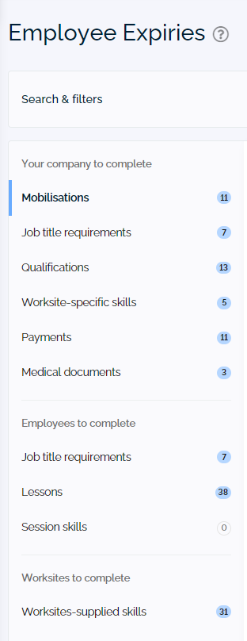

This section allows company users to view and resolve expired and expiring soon information for employee to ensure worksite requirements and access remains valid including:

- Mobilsations

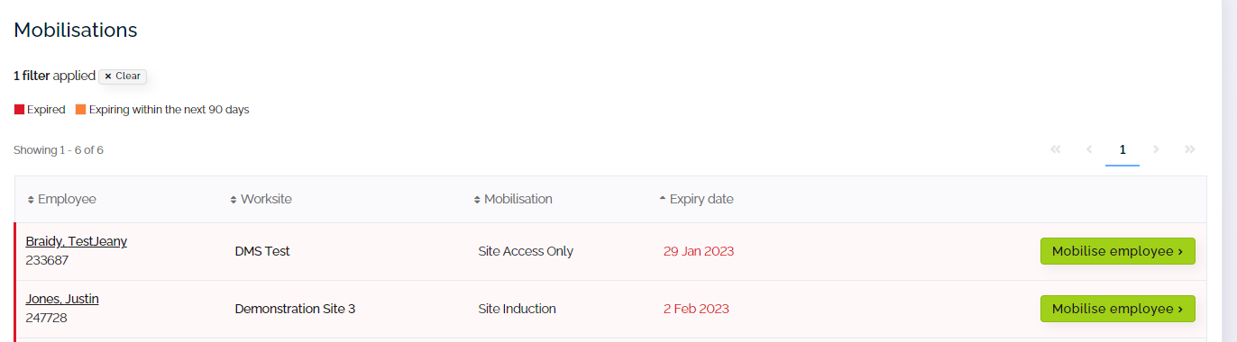

- Job title requirements - For some job title requirements, the worksite may set a time frame the requirement will be valid for before it needs to be renewed, even if the skill record on the profile expires later than this. The requirements below need to be renewed before the date shown to ensure they remain valid.
  - Click expired or expiring requirement
  - Complete required information and click 
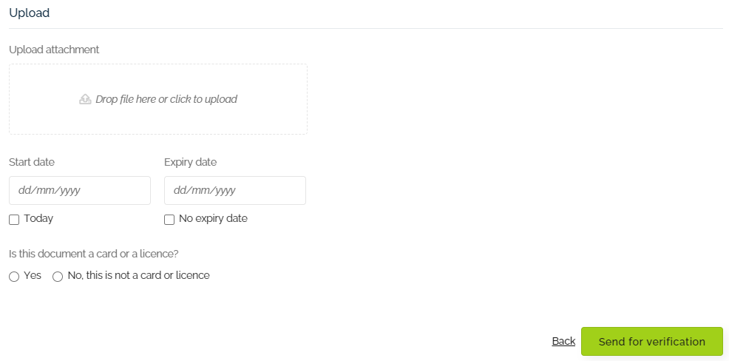

- Qualifications
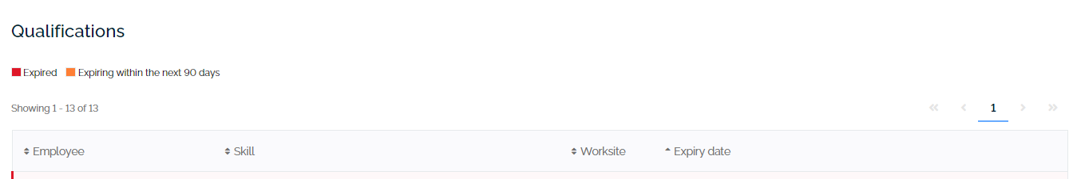
  - Click expired or expiring requirement
  - Complete required information and click

Company expiries

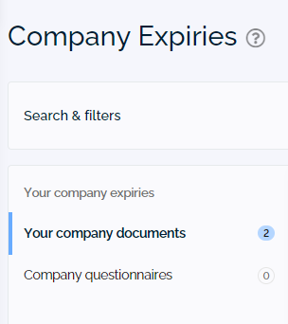

This section allows company users to view and resolve expired and expiring soon information for company documents and questionnaires to ensure worksite requirements and access remains valid including:

- Your company documents
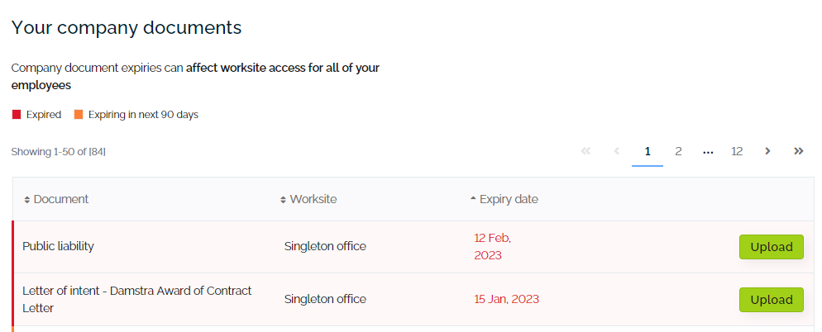

  - Click expired or expiring requirement
  - Complete required information and click

- Company questionnaires
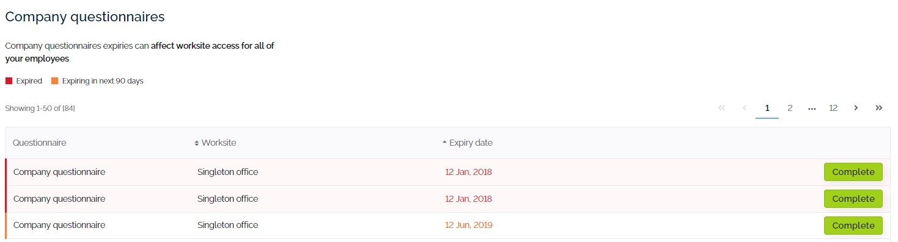

  - Click +
  - to resolve expired questionnaire.

